

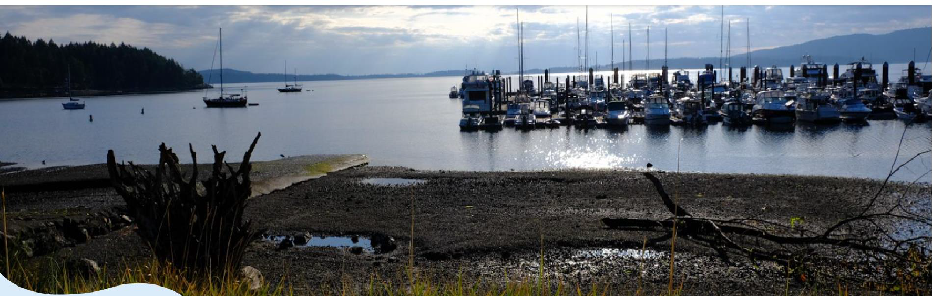

*In a continuing effort to provide information to our users, here is the latest newsletter. Please let us know what we can do to improve it.*

**Emergency Response**

MBWD staff met on the morning of November 19th to review our Emergency Response Plan (ERP) to ensure that we would be prepared to maintain service to our potable and firewater system in the event of power and communications failure during the forecasted cyclone bomb.

Our Board of Trustees would like to acknowledge the special efforts of our Operations Manager Keith Halper for seeing our community through the difficulties of power and internet outage. Keith circumvented the loss of our system communications by manual operation until the power and internet was restored.

Thank you, Keith!

**Winterization of Sprinkler Systems**

MBWD would like to remind our customers of the importance of winterizing sprinkler systems. Poorly maintained sprinkler systems are a major cause of water loss due to malfunction and freezing. Please ensure your system is properly serviced.

**RFPs, Contracts, and Projects**

Engineering

MBWD is pleased to announce our contract with McElhanney Engineering. McElhanney was the successful respondent to our RFP, and we are excited to enter into this relationship.

Customer Smart Meters

MBWD issued a Government RFP for the supply of Smart Water Meters on **November 4th.** The RFP closed on December 1st, and we are in the process of conducting an internal review. Smart Water Meters, which will allow MBWD to monitor consumer leaks and provide automated meter reading, are high on our list of upcoming improvements for our District.

Wells

The MBWD stand alone Noowick Well is one of five new Wells subject to the Water License to be approved by the Province. MBWD is a co-applicant with developers for another four Wells. The capital construction cost of integrating this Well to our distribution system is being studied at this time.

Back-up power generation

MBWD has requested a quote from McElhanney for the installation of emergency power to our system. Emergency power is high on our priority list for system improvements, and we’ll keep our customers posted on plans to install.

The Noowick Well, Emergency Power, and Smart Meters are the top three high priority projects for MBWD at this time. The scope, schedule, and budget, relating to these projects as well as available funds will dictate the timing of when we decide to proceed.

**Tolls and Taxes**

Our Board of Trustees have decided to NOT raise the **tax rate** for our customers for the year 2025.

Our water tolls / bi-monthly billing rate for the 2025 will increase by 10% or by **$5.14** per month for the base rate and by 10% for the tiered rates for those who exceed the base rate of usage. The new base amount for the bi-monthly utility bill for 2025 is $105.00.

MBWD will be mailing out copies of the October- December utility invoices but with Canada Post on strike we are encouraging our customers to contact our office to either find out the amount owing on their account or arrange for your bill to be emailed or picked up. This will ensure payments are made on time. Also, if you normally mail a cheque for payment, please contact our office if you are needing instructions on how to pay your bill online.

**Operations**

There have been no line breaks or service disruptions since the last report.

Shawnigan Creek Pumphouse safety and mechanical upgrades

* The safety improvements have been completed
* The electrical and mechanical repairs and upgrades are ongoing

Redundancy for Chlorine Injection

* Installation has been completed in our last two locations

Supervisory Control and Data Acquisition (SCADA)

* We are in the process of obtaining quotes for system upgrades to bring all of our current Wells online with our SCADA system.

Health, Safety, Security, and Environmental (HSSE)

* We have finalized our Confined Space Entry program
* We have installed security cameras at all strategic location for our District

As recently reported by our hydrologist Western Water Associates Ltd (WWAL), our engineering team, and our MBWD operations team, our water system, including the health of our aquifers and mechanical fitness of our facilities, is in a stable state and fully capable of supplying service to the community.

**Water Quality and Sustainability**

We are continuing to work with (WWAL) on the Well Monitoring Plan (WMP) which will monitor new Wells as they come online and begin to draw water from our 3 aquifers. The purpose of the WMP is to ensure that senior Well owners will not be impacted by the new Wells.

MBWD has also engaged with WWAL to provide a Source Water Protection Plan (SWPP) guided by the Province’s Comprehensive Drinking Water Source to Tap Assessment Guideline (S2TAG) Version 1.0 The S2TAG provides a structured and consistent methodology to evaluating the risks to drinking water.

These plans and studies are among several others including the efforts by Island Health Services (IHS), Mill Bay Waterworks District, the Ministry of Water Lands Resources Stewardship (WLRS), and Malahat First Nations, in a continuing effort to ensure the highest quality of water in a sustainable manner.

**Developments** Infield and Greenfield

MBWD is continuing to work with several small-scale Infield Developments within our community and the larger Greenfield Developments. We are expecting an increase in development activities in the New Year.

Of the larger greenfield developments, the Mill Springs Village and Stonebridge developments are continuing to progress.

Water services to Malahat Properties Ltd. (MPL) development is currently on hold as MBWD has suspended our co-application status with the Province for our water license. The reason for this action is that there are numerous private wells, called senior wells (those developed before 2018) surrounding proposed development, that may be negatively impacted by the operation of this well. If the development was to proceed, MBWD and our customers would then be forever obligated to mitigate any supply issues caused by interference. We believe this is an untenable risk. MBWD and MPL are attempting to navigate through the next steps.

**Holiday Office Closure**

The MBWD office will be closed from December 23 – January 5th inclusive; an Operator will be available for emergencies.

*Holiday message from MBWD Staff and Board of Trustees*

*Season’s greetings!*

*Our fondest memories of the past year involve providing high-quality service to high-quality customers like you. Happy holidays, and the happiest new year!*

Gary Orton

MBWD Board Chair